**Problem 1: Venn Diagrams**

1.)

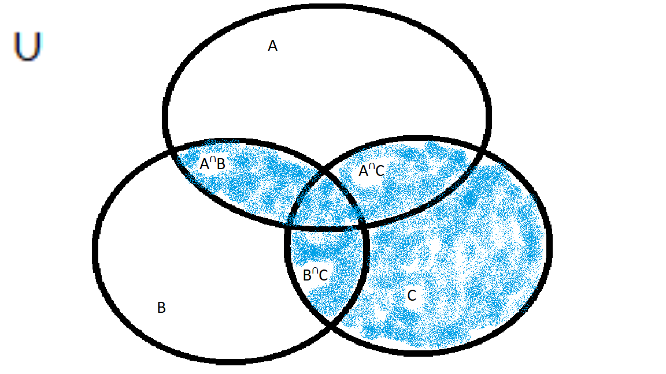

2.)

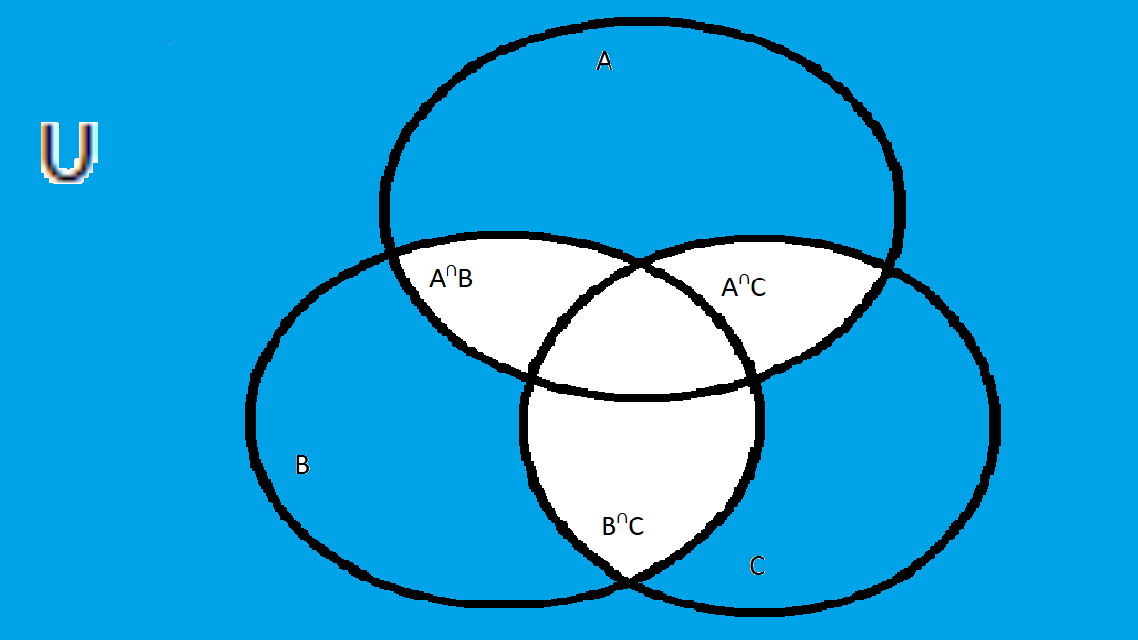

3.)

**Problem 2: Proof of Laws**

1.) prove absorption law $A∪\left(A∩B\right)=A$ by twice-applied universal generalization

Case 1: $A∪\left(A∩B\right)=A$

$x∈A∪\left(A∩B\right)$ Consider an element x

$x∈A or x∈(A∩B)$ Definition of Union

Case 1.1: $x∈(A∩B)$

Case 1.1 $x∈A$ Definition of intersection

Case 1.2 $x∈A$ Definition of $∈$

Any case of $x∈A∪\left(A∩B\right), x∈A$ Universal Generalization

$$∴A∪\left(A∩B\right)=A$$

Case 2: $A=A∪(A∩B)$

$x∈A$ Consider an element x

$x∈B or x∉B$ Without loss of generality

Case2.1: $x∈B$

Case 2.1: $x∈(A∩B )$ Definition of Intersection

Case 2.2: $x∉B$

Case 2.2: $x∈(A∪B)$ Definition of Union

Case 2.2: $x∈A$ Definition of Union

$$∴A=A∪(A∩B)$$

2.) prove associative law $A∩\left(B∩C\right)=(A∩B)∩C$ by membership table

|  |  |  |  |  |  |  |  |
| --- | --- | --- | --- | --- | --- | --- | --- |
| $$A$$ | $$B$$ | $$C$$ | $$(B∩C)$$ | $$(A∩B)$$ | $$A∩(B∩C)$$ | $$\left(A∩B\right)∩C$$ | $$A∩\left(B∩C\right)⊆\left(A∩B\right)∩C$$ |
| Y | Y | Y | Y | Y | Y | Y | Y |
| Y | Y | N | N | Y | N | N | Y |
| Y | N | Y | N | N | N | N | Y |
| Y | N | N | N | N | N | N | Y |
| N | Y | Y | Y | N | N | N | Y |
| N | N | N | N | N | N | N | Y |
| N | N | Y | N | N | N | N | Y |
| N | Y | N | N | N | N | N | Y |

**Problem 3: Proof of Equalities**

1.) Prove $(A∪B)⊆(A∪B∪C)$

$x∈(A∪B)$ Consider an element x

$x∈A or x∈B$ Definition of Union

Case 1.1: $x∈A$

$x∈(A∪B∪C)$ Definition of Union

Case 1.2: $x∈B$

$x∈(A∪B∪C)$ Definition of Union

$∴(A∪B)⊆(A∪B∪C)$ Universal generalization

2.) $\left(A∩B∩C\right)⊆(A∩B)$

|  |  |  |  |  |  |
| --- | --- | --- | --- | --- | --- |
| **A** | **B** | **C** | $$\left(A∩B∩C\right)$$ | $$(A∩B)$$ | $$\left(A∩B∩C\right)⊆(A∩B)$$ |
| Y | Y | Y | Y | Y | Y |
| Y | Y | N | N | Y | Y |
| Y | N | Y | N | N | Y |
| Y | N | N | N | N | Y |
| N | Y | Y | N | N | Y |
| N | Y | N | N | N | Y |
| N | N | Y | N | N | Y |
| N | N | N | N | N | Y |

3.) $\left(A-C\right)∩\left(C-B\right)=∅$

|  |  |  |  |  |  |  |
| --- | --- | --- | --- | --- | --- | --- |
| **A** | **B** | **C** | $$\left(A-C\right)$$ | $$(C-B)$$ | $$\left(A-C\right)∩(C-B)$$ | $$\left(A-C\right)∩\left(C-B\right)=∅$$ |
| Y | Y | Y | N | N | N | Y |
| Y | Y | N | Y | N | N | Y |
| Y | N | Y | N | Y | N | Y |
| Y | N | N | Y | N | N | Y |
| N | Y | Y | N | N | N | Y |
| N | Y | N | N | N | N | Y |
| N | N | Y | N | Y | N | Y |
| N | N | N | N | N | N | Y |

4.) $\left(B-A\right)∪\left(C-A\right)=\left(B∪C\right)-A$

$x∈\left(B-A\right)∪\left(C-A\right)=\left(B∪C\right)-A$ Consider an element x

$x∈B \& x∉A or x∈C \& x∉A$ Definition of Union and Relative Complacent

$$Case 1.1 x∈B \& x∉A$$

$x∈\left(B∪C\right)- A$ Definition of Union and relative complacent

Case 1.2 $x∈C \& x∉A$

$x∈\left(B∪C\right)- A$ Definition of Union and relative complacent

$∴\left(B-A\right)∪\left(C-A\right)=\left(B∪C\right)-A$ Universal Generalization

$x∈\left(B∪C\right)-A=\left(B-A\right)∪\left(C-A\right)$ Consider an element x

$x∈B-A or$ $x∈C-A$ Definition of Union

Case 2.1: $x∈B-A$

$x∈\left(B-A\right)∪(S)$ Definition of Union, S = any set

$x∈\left(B-A\right)∪(C-A)$ S = any set

Case 2.2 $x∈(C-A)$

$x∈\left(C-A\right)∪(S)$ Definition of Union, S = any set

$x∈\left(C-A\right)∪(B-A)$ S = any set

$∴\left(B∪C\right)-A=\left(B-A\right)∪\left(C-A\right)$ Universal Generalization

**Problem 4: Set Equality Laws**

$$1.) \left(\left(A∩B\right)∪\left(A∩¬B\right)∪\left(¬A∩B\right)\right)=\left(A∪B\right)$$

$A∩\left(B∪¬B\right)∪(¬A∩B)$ Distributive

$A∩U∪(¬A∩B)$ Inverse

$A∪(¬A∪B)$ Identity

$\left(A∪¬A\right)∩(A∪B)$ Distributive

$U∩(A∪B)$ Inverse

$(A∪B)$ Identity

**Problem 5: Disproof**

$1.) \left(A-B\right)=\left(B-A\right)$ is not always true

|  |  |  |  |  |
| --- | --- | --- | --- | --- |
| **A** | **B** | $$\left(A-B\right)$$ | $$(B-A)$$ | $$\left(A-B\right)⊆(B-A)$$ |
| Y | Y | N | N | Y |
| Y | N | Y | N | Y |
| N | Y | N | Y | N |
| N | N | N | N | Y |